Titles Should Be Composed Using Times New Roman Bold Font (17 pt) with a Recommended Maximum of 20 Words

First Author¹, Second Author^{2*}, Third Author²

¹ Department, Faculty, Institution, City, Country.
² Department, Faculty, Institution, City, Country.

*Corresponding author: [e-mail of the corresponding author]

Abstract: A brief and factual abstract is mandatory. In a single self-contained paragraph of about 150 to 220 words it states the research purpose, the method and the data, the key findings with their main numbers, and the conclusion with its scope. Omit citations and equations, avoid uncommon abbreviations, and define any abbreviation at first use. Report only what the study itself supports. Write it in Times New Roman 10 pt, justified.
Keywords : keyword one; keyword two; keyword three. (max 5 keywords)

Received: Month DD, YYYY | Revised: Month DD, YYYY | Accepted: Month DD, YYYY | Published: Month DD, YYYY

Introduction
The primary text is set in a justified single-column layout on A4 paper with margins of 2.5 cm at the left and top and 2 cm at the right and bottom. Compose the manuscript in Microsoft Word with this template and keep its styles, headers, and footers: Times New Roman 11 pt, line spacing 1.15, and a first-line indent of 0.75 cm for body paragraphs. Write in English only, in American spelling. The page limit is a minimum of 8 and a maximum of 12 pages for original research articles, and 16 pages for review or survey papers. Figure and table captions use 10 pt, table text 9 pt, and the reference list 10 pt. Yellow highlighting marks a placeholder: the header fields on the first page and the date box are completed at production, and any other highlighted text in a manuscript is something the authors still have to confirm, so clear it before submission. Headings that carry a label in parentheses in this template, such as (Optional), show the requirement; delete the label in the manuscript, and delete an optional section that does not apply. The template is available at https://journal.jti.fatek.untad.ac.id/syntia.
The article title must use the fewest words that convey the content; about 12 words or fewer is advisable and 20 is the maximum. Use title case. Leave out acronyms, abbreviations, and methodological detail unless the paper introduces a new method. Titles feed information-retrieval systems, so avoid long formulas with subscripts and avoid empty openers such as “A study of”, “Investigation of”, “Implementation of”, “Effect of”, “Analysis of”, and “Design of”. When two or more methods are compared, join them with “and”, as in “Random Forest and XGBoost for …”, and not with “versus” or “vs.”. Indexing databases take keywords from the title, and a poorly worded title can keep the paper from its readers.
A brief and factual abstract is mandatory. It is a single paragraph of about 150 to 220 words that states the research purpose, the method and the data, the key findings with their main numbers, and the primary conclusion with its scope, so that the text fits the abstract box. Because abstracts are often read alone, they must be self-contained: no citations, no equations, and no uncommon abbreviations. Report only what the study itself supports. Below the abstract, list 5 to 7 keywords in American English, separated by semicolons and ending with a period. Put them in alphabetical order, in lowercase except for proper nouns and acronyms, and avoid broad terms, plural forms, and compound concepts.
The author block lists authors by full name. Give each author the number of the affiliation, and let authors who share an institution share one number; mark the corresponding author with an asterisk. State the e-mail address of the corresponding author once, as a hyperlink in the line below the affiliations; there are no e-mail lines for the other authors. Place the ORCID icon after the name of every author who has an ORCID iD and link it to the full iD address (https://orcid.org/0000-0000-0000-0000). In the running header at the top of the following pages, write the authors with initials and surnames (“A. Author and B. Author” for two authors, “A. Author, B. Author, and C. Author” for three or more) and give the title in quotation marks.
The Introduction must contain: i) enough background for readers from other fields, ii) a precise statement of the research problem, iii) the relevant literature, iv) the proposed method or solution, and v) the novel contribution of the work, in about four to eight paragraphs. State the research questions or objectives explicitly (RQ1, RQ2, and so on), summarize the contributions in one paragraph, and close with a sentence that outlines the organization of the paper. The literature review does three jobs across the manuscript: in the Introduction it separates the present work from existing publications, in the Method it guides the procedures, and in the Results and Discussion it supplies evidence for interpreting the findings. Cite with IEEE numbered style, as in [1], and format foreign-language terms in italics. Write numbers with a decimal point and commas as thousands separators, as in 46,485.
A complete manuscript follows the IMRaD structure: 1. Introduction, 2. Method, 3. Results and Discussion, and 4. Conclusion. Section and subsection titles stand on their own lines and are numbered in sequence. After the Conclusion, the unnumbered sections follow in this order: Acknowledgments, Funding Information, AI Disclosure Statement, Author Contributions Statement, and References. The remainder of this template shows each of these parts in turn: Section 2 describes the Method, Section 3 the Results and Discussion, and Section 4 the Conclusion.

Method
Present the research in chronological order: the research framework, the procedure (algorithms, pseudocode, or equivalent), the testing procedure, and the data collection. Support the description with citations so that readers can judge it and repeat it [2]. Describe the data source and how the data were collected, the sample size and the class balance, the split between training, validation, and test data and the stage at which the split is made, and the evaluation metrics. Figures and tables are centered, numbered in order of appearance, placed after the paragraph that first cites them, and cited in the text as Fig. 1 and Table 1; equations are cited as Eq. (1) and other sections as Section 3.2.
2.1. Sub-heading of the method
Sub-headings carry the section number and a period, for example 2.1., followed by a tab and the title in bold. Do not use a third heading level; run-in lead sentences or lists serve better. Name each sub-heading by its topic in a few words, such as Data, Models and training, or Evaluation and statistics. Fig. 1 is an example of a single-panel figure, here the workflow of a study; a flowchart or system diagram of this kind usually opens the Method.
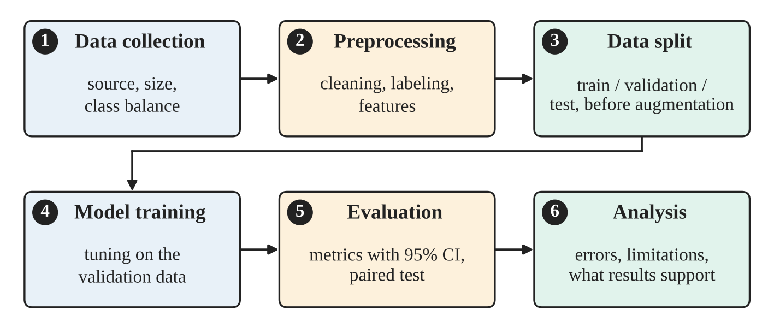
Figure 1. Example of a single-panel figure: the workflow of a classification study. The caption is placed below the figure. Figures must be legible at print size and have a resolution of at least 300 DPI. Use a colorblind-safe palette (for example, Okabe–Ito) and add numbers, markers, hatching, or direct labels, so that no information depends on color alone.
2.2. Evaluation protocol
Equations are centered on the line and numbered in sequence, with the number in parentheses at the right margin, as in Eq. (1). Build them with the Microsoft Word equation editor or MathType, not as pictures. Define the evaluation metrics here, in the Method, and do not define them again in the Results.
$Accuracy=\frac{TP+TN}{TP+TN+FP+FN}$ (1)
Define every symbol in the text that follows the equation: here TP, TN, FP, and FN are the counts of true positives, true negatives, false positives, and false negatives. State how uncertainty is measured (for example, a confidence interval for each proportion) and which test is used to compare methods on the same data, so that every claim in the Results can be traced to a stated procedure.
2.3. Reproducibility and ethics
Give the software and library versions, the random seeds, and the hardware. Say where the code and the data are available, or that they are available from the corresponding author on reasonable request, and give the license of any public dataset. State the ethics approval or consent obtained, or the reason none was needed, for example public data without personal identifiers.

Results and Discussion
This section is the most important part of the paper. Present the findings clearly and briefly, as a synthesis of the scientific results and not as raw data. Give each main number with its uncertainty and name the test behind every comparison. State how your results differ from those of earlier studies [3], noting that datasets and protocols often differ, and discuss what the results mean and what they do not show. Findings may appear as figures, charts, tables, and other visual formats. The discussion may be divided into subsections, preferably organized around the research questions or objectives stated in the Introduction.
3.1. Sub-heading of the discussion
Cite other work to avoid plagiarism. Refer to a reference by its number, as in [1], or [2], [3] for several references, and use three or more consecutive numbers as a range, as in [1]–[3]. At the start of a sentence write “Ref. [1]”. For a reference with more than three authors, name only the first author followed by et al. in the text (for example, LeCun et al. [1]). Examples of reference items of different categories are given in the References section [1]–[9].
3.2. Figures with several panels
A figure with several panels is one numbered figure, as in Fig. 2. Label the panels (a), (b), and so on in bold at the top left of each panel, describe them in the caption in that order, and cite them in the text as Fig. 2a and Fig. 2b. Panels that compare methods share the same colors, markers, and axis ranges. Draw interval estimates, such as the confidence intervals in Fig. 2a, as points with error bars and not as truncated bars. Overlapping intervals alone do not show that a difference exists, so report the paired test as well.
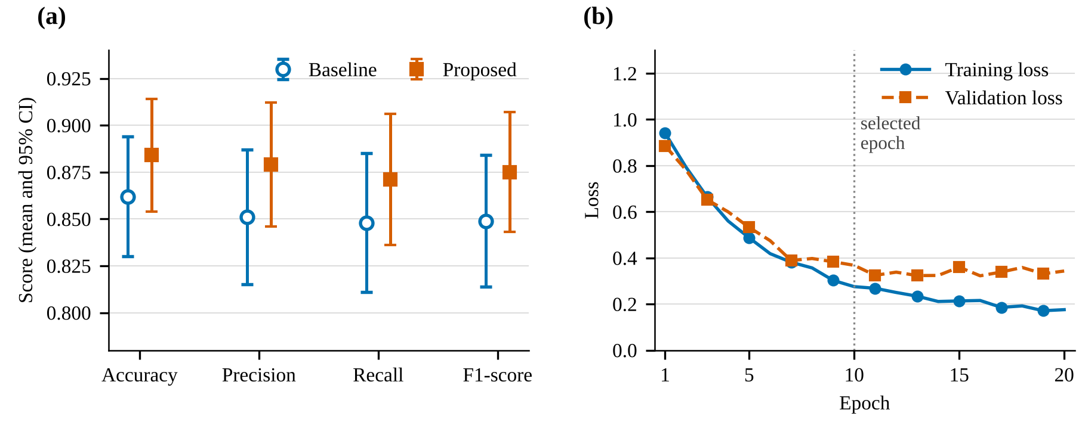
Figure 2. Example of a figure with two panels: (a) mean and 95% confidence interval of four metrics for two methods; (b) training and validation loss by epoch. The panels are labeled inside the figure and described in the caption. The values are illustrative and do not come from any study.
3.3. Sub-heading of the discussion
Tables follow an open format with horizontal rules only and no vertical borders, as in Table 1. The caption goes above the table, and a note on sources or abbreviations goes below it in 9 pt italic. Put the unit in the column heading and keep the number of decimals the same within a column.
Table 1. Example of an open-format table.
Method | Accuracy (%) | 95% CI (%) | F1-score
Baseline | xx.x | xx.x–xx.x | 0.xxx
Proposed | xx.x | xx.x–xx.x | 0.xxx
Source or note: state where the numbers come from, define abbreviations, and give the sample size on which each interval is computed.
3.4. Limitations and what the results support
End the discussion with the limits of the study: the source and size of the data, the quality of the labels, possible leakage or circularity, class imbalance, a single split or a single dataset, and what a claim can therefore support. Do not claim that one method is better than another unless a paired test or an interval supports it; when it does not, say that the difference is not established. Report negative and null results as they are, and do not add data, citations, or results that the study did not produce.

Conclusion
The conclusion answers the research objectives, or the research questions of the Introduction, in a clear and brief statement. Do not copy the abstract or restate the results one by one, and do not introduce new results or citations. Explain the practical applications or recommendations that follow from the findings, and state the main limitation and the next step.

Acknowledgments (Optional)
Thank the people and organizations that contributed to the research, with emphasis on those who provided financial support: academic advisors, funding bodies, and other contributors such as editors, data-entry staff, field experts, and suppliers of materials or resources. Delete this section if it does not apply.

Funding Information (Optional)
Name the organizations that financed the research and give grant numbers where relevant. If there was no financial support, write: Authors declare no funding was involved.

AI Disclosure Statement (Mandatory)
Declare any use of generative AI and AI-assisted technologies in the preparation of the manuscript, including drafting or revising text, writing or running code, analyzing data, and producing figures or formatting, and say what each was used for. State that the authors verified the output, checked every reference against its original source, and accept full responsibility for the content. If no such tools were used, say so. Edit the following example so that it describes your actual use:
The authors used Generative AI and AI-Assisted Technologies throughout the preparation of this manuscript: to draft and revise portions of the text, to write and run the scripts behind the experiments and statistical analyses, to generate the figures, and to format the document from the authors' own research data and source code. The authors verified the scripts and their outputs, reviewed the resulting text, cross-checked every reference against its original source, and accept full responsibility for the content of this publication.

Author Contributions Statement (Mandatory)
The journal uses the Contributor Roles Taxonomy (CRediT) to credit each author, reduce authorship disputes, and encourage collaboration. At least two authors are suggested, one of them the corresponding author, who handles all communication about the manuscript and keeps the co-authors informed through submission, revision, and publication. Use the 14 CRediT roles: Conceptualization, Data Curation, Formal Analysis, Funding Acquisition, Investigation, Methodology, Project Administration, Resources, Software, Supervision, Validation, Visualization, Writing – Original Draft, and Writing – Review and Editing. Credit each author with the roles that describe the contribution actually made, using the exact CRediT names, and give the writing roles (Writing – Original Draft, Writing – Review and Editing) to those who wrote or revised the text. Give one line per author, as below.
First Author: Conceptualization, Methodology, Software, Investigation, Formal Analysis, Data Curation, Visualization, Writing – Original Draft.
Second Author: Supervision, Validation, Writing – Review and Editing.
Third Author: Validation, Writing – Review and Editing.

References
Primary citations should be international journals and conference proceedings. All references must be relevant and current, with a minimum of 16 references for original research articles and 20 for review papers. Number the references in the order of first citation, cite every item in the text, check each one against its original source, and give the DOI whenever one exists; do not list work that you have not read or cannot verify. Follow the IEEE style, using a reference manager such as EndNote, Mendeley, or Zotero with the IEEE option. Keep the format uniform, as in the examples below (10 pt). In the reference list, name all authors for up to six authors, and use et al. only when the names are not given or there are more than six authors.
Journal/Periodicals
Basic format: J. K. Author, “Title of paper,” Abbrev. Title of Journal/Periodical, vol. x, no. x, pp. xxx–xxx, Abbrev. Month, year, doi: xxx. If the journal numbers articles instead of pages, replace pp. xxx–xxx with Art. no. xxx.
[1] Y. LeCun, Y. Bengio, and G. Hinton, “Deep learning,” Nature, vol. 521, no. 7553, pp. 436–444, May 2015, doi: 10.1038/nature14539.
Conference Proceedings
Basic format: J. K. Author, “Title of paper,” in Abbreviated Name of Conf., (location of conference is optional), year, pp. xxx–xxx, doi: xxx.
[2] A. Krizhevsky, I. Sutskever, and G. E. Hinton, “ImageNet classification with deep convolutional neural networks,” in Proc. 25th Int. Conf. Neural Inf. Process. Syst. (NIPS), Lake Tahoe, NV, USA, 2012, pp. 1097–1105.
Book
Basic format: J. K. Author, “Title of chapter in the book,” in Title of His Published Book, X. Editor, Ed., xth ed. City of Publisher, State (only U.S.), Country: Abbrev. of Publisher, year, ch. x, sec. x, pp. xxx–xxx. For a chapter in a book series, give the series name after the book title, as in [4].
[3] S. J. Russell and P. Norvig, Artificial Intelligence: A Modern Approach, 4th ed. Hoboken, NJ, USA: Pearson, 2021.
[4] T. Joachims, “Text categorization with support vector machines: Learning with many relevant features,” in Machine Learning: ECML-98, Lecture Notes in Computer Science. Berlin, Germany: Springer, 1998, pp. 137–142, doi: 10.1007/BFb0026683.
Theses (B.S., M.S.) and Dissertations (Ph.D.)
Basic format: J. K. Author, “Title of thesis,” M.S. thesis, Abbrev. Dept., Abbrev. Univ., City of Univ., Abbrev. State, year; and J. K. Author, “Title of dissertation,” Ph.D. dissertation, Abbrev. Dept., Abbrev. Univ., City of Univ., Abbrev. State, year.
[5] T. Mikolov, “Statistical language models based on neural networks,” Ph.D. dissertation, Faculty of Information Technology, Brno University of Technology, Brno, Czech Republic, 2012.
Preprints
Basic format: J. K. Author, “Title of preprint,” arXiv:xxxx.xxxxx, year. Cite the peer-reviewed version instead when one has been published.
[6] D. Sahoo, C. Liu, and S. C. H. Hoi, “Malicious URL detection using machine learning: A survey,” arXiv:1701.07179, 2017.
Standards and Technical Reports
Basic format: Organization, “Title of document,” Type and number of the document, Abbrev. Month, year, doi: xxx.
[7] National Institute of Standards and Technology, “Secure hash standard (SHS),” Federal Information Processing Standards Publication 180-4, Aug. 2015, doi: 10.6028/NIST.FIPS.180-4.
Online Documents
Basic format: J. K. Author or Organization, “Title of document,” Site or series, year. [Online]. Available: URL (accessed Abbrev. Month DD, year). When the page has no personal author, begin with the title, as in [8].
[8] “Solidity 0.8.26 documentation.” [Online]. Available: https://docs.soliditylang.org/en/v0.8.26/ (accessed Oct. 12, 2026).
Sources in Another Language
Basic format: as for the type of source, with the title kept in its original language and the name of the language in parentheses after the title.
[9] J. S. G. Sinaga, N. Sitorus, and S. L. Samosir, “Analisis kinerja algoritma hash pada keamanan data: Perbandingan antara SHA-256, SHA-3, dan Blake2” (in Indonesian), Jurnal Quancom: Quantum Computer Jurnal, vol. 2, no. 2, pp. 9–16, Dec. 2024, doi: 10.62375/jqc.v2i2.432.

